38.3: a) 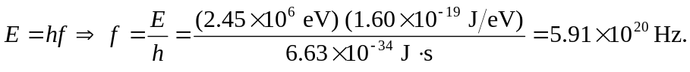
b) 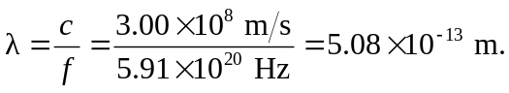
c) is of the same magnitude as a nuclear radius.

